CJ Toohey

Frequency Domain Time Series Analysis

Homework 4

1. See attached sheets

2. The eight plots are shown below. Smoothing effectively removes high frequency content from the periodogram. There are several high frequency “lobes” in the smoothed periodogram which directly coincide with the sidelobes of the transfer function.

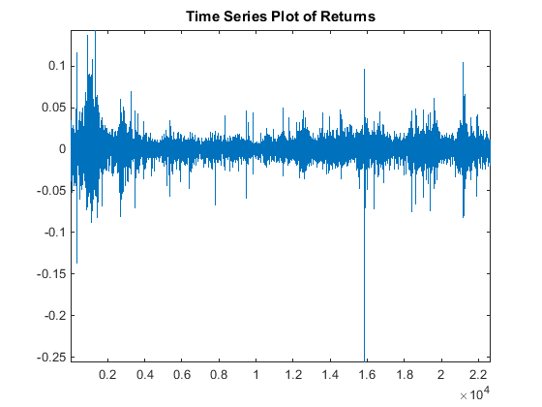

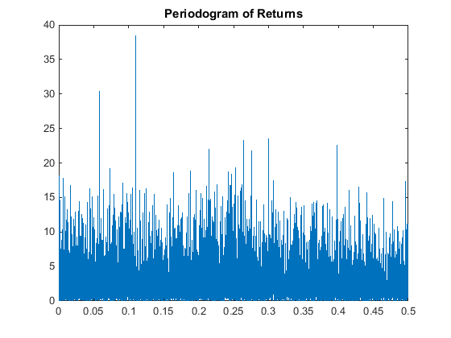

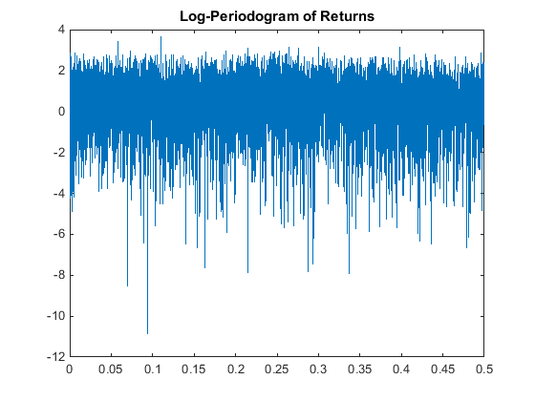

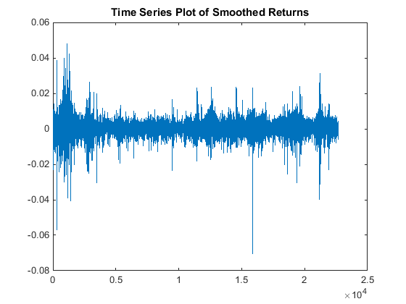

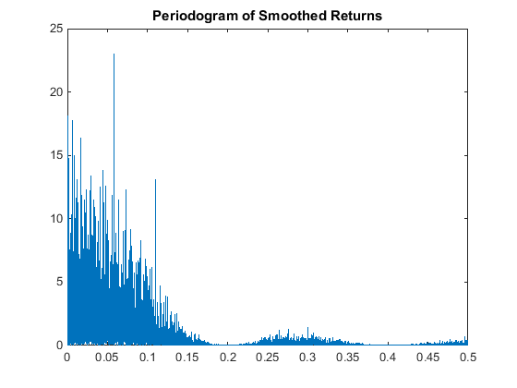

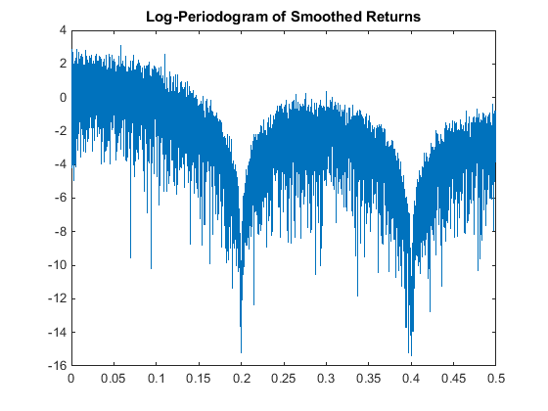

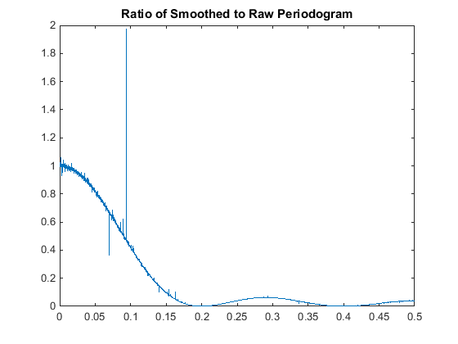

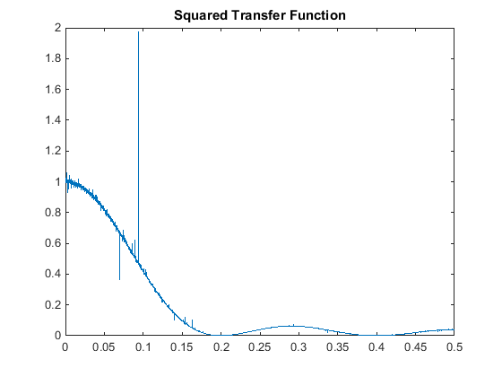

3. See attached sheets

4. See attached sheets

5. See attached sheets

6. The dowdif and co2res datasets were tested for periodicity using the Fisher test. The co2res periodogram had 190 ordinates and the dowdif periodogram had 11328 ordinates. The max to mean ratio for the co2res periodogram was 168.516 and the max to mean ratio for the dowdif periodogram was 13.493. The probability that the max to mean ratio exceeds the observed max to mean ratio is given by P = 1 – exp(-M\*exp(-max/mean)). For the co2res dataset, this is approximately 0. For the dowdif dataset, this is approximately .016. In either case, I would conclude from the Fisher test that the periodogram peak corresponds to a real cycle in the data and not to statistical fluctuations in the periodogram due to noise.

7. A plot of the periodogram of x is shown below. The expected value of the periodogram evaluated at the fourier frequencies is sigma^2 since the periodogram values are distributed according to an exponential distribution of mean sigma^2. The sample mean of the periodogram values is 1.0903. Using a two-sided z-test, the computed p-value is .9281 so the null hypothesis cannot be discarded. This means that the observed sample mean is consistent with the underlying theoretical value. The largest peak in the periodogram occurs for j = 2, which corresponds to a cycle period of 100/2 = 50 samples. The max to mean ratio for the periodogram is 4.2. The probability that the max to mean ratio exceeds the observed max to mean ratio is given by P = 1 – exp(-M\*exp(-max/mean)), which for this problem is .5131. With a threshold .05 significance level, we would conclude that the observed peak is not statistically significant (i.e. does not correspond to a true cycle in the data) and is due to statistical fluctuations in the periodogram due to noise.

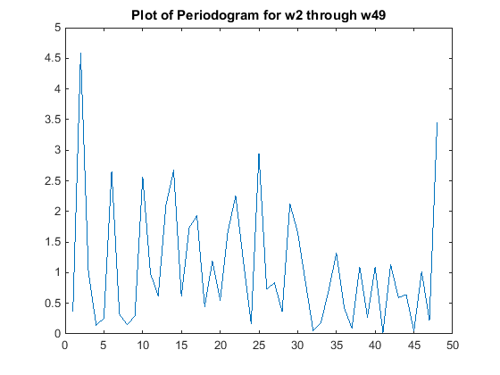

8. I wrote the autocovariance function in Matlab. The code is:

x = ones(100,1);

xpadded = [x;zeros(100,1)];

Ipadded = abs(fft(xpadded)).^2;

cr = ifft(Ipadded);

cr = cr(1:100)

The plot of the covariance function for a sequence of 100 ones is shown below. This plot agrees with my intuition. At lag 0, there is maximal overlap and the c0 should equal 100. For each increment in the lag operator, the overlap decreases by 1 and hence the autocovariance should decrease by 1.

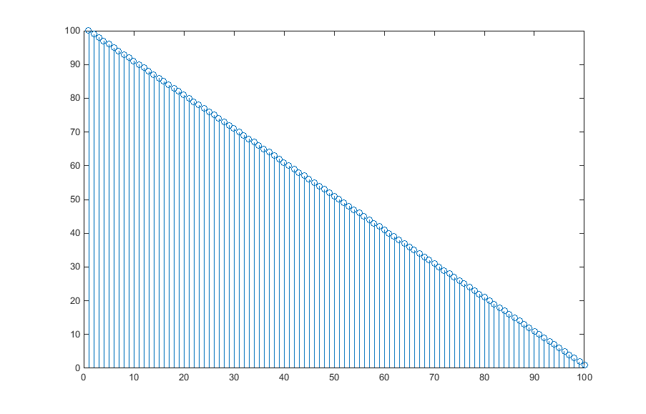

9. See attached sheet.